Lab-3

Supplier database

**Code:**

**create database supplier;**

**use supplier;**

**create table Suppliers(**

**sid int primary key,**

**sname varchar(20) not null,**

**address varchar(20)not null);**

**create table Parts(**

**pid int primary key,**

**pname varchar(20) not null,**

**color varchar(10) not null);**

**create table Catalog(**

**sid int,**

**pid int,**

**cost real not null,**

**primary key(sid,pid),**

**foreign key(sid) references Suppliers(sid),**

**foreign key(pid) references Parts(pid));**

**desc suppliers;**

**desc parts;**

**desc catalog;**

**insert into Suppliers**

**values**

**(10001,"Acme Widget","Bangalore"),**

**(10002,"Johns","Kolkata"),**

**(10003,"Vimal","Mumbai"),**

**(10004,"Reliance","Delhi");**

**select * from suppliers;**

**insert into Parts**

**values**

**(20001,"Book","Red"),**

**(20002,"Pen","Red"),**

**(20003,"Pencil","Green"),**

**(20004,"Mobile","Green"),**

**(20005,"Charger","Black");**

**select * from parts;**

**insert into Catalog**

**values**

**(10001,20001,10),**

**(10001,20002,10),**

**(10001,20003,30),**

**(10001,20004,10),**

**(10001,20005,10),**

**(10002,20001,10),**

**(10002,20002,20),**

**(10003,20003,30),**

**(10004,20003,40);**

**select * from catalog;**

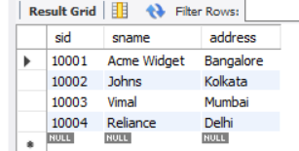 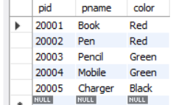 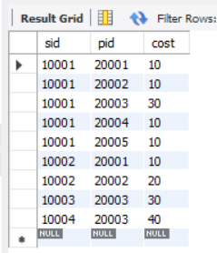

Queries and screenshot:

**1**. select pname,s.sname from Parts p,Catalog c,Suppliers s

where

c.sid in (select distinct sid from Suppliers) and

p.pid=c.pid and

c.sid=s.sid;

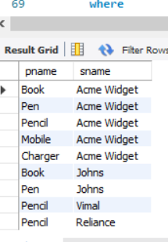

**2**.-- Find the snames of suppliers who supply every part.

select s.sname from Catalog c,Suppliers s

where

c.sid=s.sid

group by c.sid

having count(c.sid)=(select count(*) from Parts);

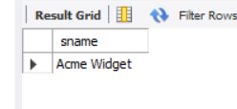

**3.**-- Find the snames of suppliers who supply every red part.

select s.sname,count(*) from Catalog c,Suppliers s,Parts p

where

c.sid=s.sid and

p.pid=c.pid and

c.pid in (

select c.pid from Catalog c,Parts p where c.pid=p.pid and

p.color="red"

group by c.pid

)

group by s.sid

having count(*)=(

select count(*) from Parts where color="red" group by color

);

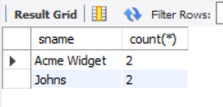

**4**.-- Find the pnames of parts supplied by Acme Widget Suppliers and by no one else.

select p.pname from Parts p,Suppliers s,Catalog c

where

s.sid=c.sid and

p.pid=c.pid and

s.sname="Acme Widget" and

c.pid not in (select c.pid from Catalog c,Suppliers s where s.sname <> "Acme Widget"and c.sid=s.sid)

group by c.pid;

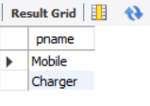

**5.**-- Find the sids of suppliers who charge more for some part than the average cost of that

-- part (averaged over all the suppliers who supply that part).

select sid from Catalog c1

where cost>(select avg(cost) from Catalog

where c1.pid=pid

group by pid)

;

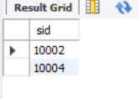

**6**-- For each part, find the sname of the supplier who charges the most for that part.

select sid,pid from Catalog c1

where

cost=(select max(cost) from Catalog

where c1.pid=pid

group by pid)

;

